System and Software Architecture Description (SSAD)

City of Los Angeles Personnel Department Mobile Applications

Team 02

Anushree Sridhar - Software Architect

Shreya Kamani - Project Manager

Divya Reddy - Requirements Engineer

Pattra Thongprasert - Operation Concept Engineer

Abhishek Trigunayat - Prototyper

Travis Jones - Feasibility Analyst

William Everton - IIV and V

Image21.png

USC-CSSE

# Version History

| Date | | Author | | | Version | | Changes made | Rationale | | |
| --- | --- | --- | --- | --- | --- | --- | --- | --- | --- | --- |
| 10/16/13 | | Anushree | 1.0 | | Added:   * System context diagram * Use case diagram and descriptions * Artifacts and information diagram | | | Initial technology independent draft of SSAD for FC package |
| 10/23/13 | | Anushree | 1.1 | | * Modified diagrams | | | * Modifications made based on the FC ARB |
| 10/26/13 | | Anushree | 1.2 | | * Modified use case descriptions (post and pre conditions, flow) | | | * Modifications made on the basis of “SSAD in DC” lecture to the use case descriptions |
| 12/02/13 | | Anushree | 1.3 | | Added:   * Hardware component diagram * Software component diagram * Deployment diagram * Class diagrams * Sequence diagrams | | | * Completed SSAD according to the draft DC package specifications |
| 12/09/13 | | Anushree | 1.4 | | Use cases were updated | | | * Updated use cases with feedback from FC package |

# Table of Contents

System and Software architecture description i

Version History ii

Table of Contents iii

Table of Tables iv

Table of Figures v

1.Introduction 1

1.1Purpose of the SSAD 1

1.2Status of the SSAD 1

2.System Analysis 2

2.1System analysis overview 2

2.2System analysis rationale 14

3.Technology independent model 15

4.Technology specific system design 16

4.1Design overview 16

4.2Design rationale 21

5.Architectural Styles, Patterns and Frameworks……………………………………………………………..22

# Table of Tables

*Table 1: Actors Summary 2*

*Table 2: Artifacts and Information Summary 3*

*Table 3: Hardware Component Description 16*

*Table 4: Software Component Description 17*

*Table 5: Design Class Description 18*

*Table 6: Interface Class Description 19*

*Table 7: Architectural Styles, Patterns, and Frameworks 22*

Note: Process Description tables can be found in pages: 4-12

# Table of Figures

*Figure 1: System Context Diagram 2*

*Figure 2: Artifacts and Information Diagram 3*

*Figure 3: Process Diagram 3*

*Figure 4: Hardware Component Class Diagram 15*

*Figure 5: Software Component Class Diagram 15*

*Figure 6: Deployment Diagram 16*

*Figure 7: Design Class Diagram 17*

*Figure 8: Interface Class Diagram 19*

*Figure 9: Process Realisation - Subscribe for notification* *20*

*Figure 10: Process Realisation – Create / update user profile 20*

*Figure 11: Process Realisation – Process RSS feed and Send Notifications 21*

# Introduction

* 1. **Purpose of the SSAD**

The purpose of the System and Software Architecture Description

is to describe what the proposed system will do, how it will do those functions, who will be using it, what the flow of events is and where it will be deployed and operate. It shows how the system interacts with the external environment and how the various components of the system interact. It contains a complete description of the design of the proposed system and its working.

* 1. **Status of the SSAD**

The SSAD is being submitted for the Development Commitment Review (FCR). It includes the technology specific design of the system being developed.

# 2.System Analysis

**2.1.** **System Analysis Overview**

The primary purpose of the City of Los Angles Personnel Department Mobile Application is to provide job seekers a means of subscribing for notifications about openings in jobs in the city of Los Angeles, which they are interested in. The application enables job seekers to view a list of currently open jobs, search for a job they are interested in and subscribe to receive notifications. It then sends a notification to the job seeker when a job they have subscribed to opens up.

**2.1.1. System Context**

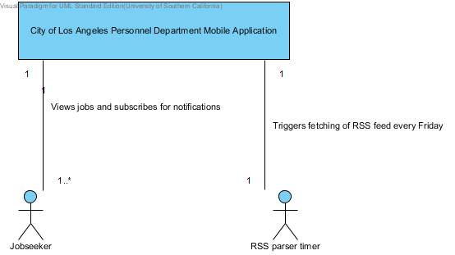

**Figure 1: System Context Diagram**

|  |  |  |
| --- | --- | --- |
| ID | Name | Related Use Cases |
| AC01 | Jobseeker | Search all existing jobs Create / update user profile View job descriptions View open jobs Subscribe for notifications Receive notifications when job opens |
| AC02 | RSS Parser timer | Process Neogov RSS feed |

**Table 1: Actors Summary**

**2.1.2.** **Artifacts and information**

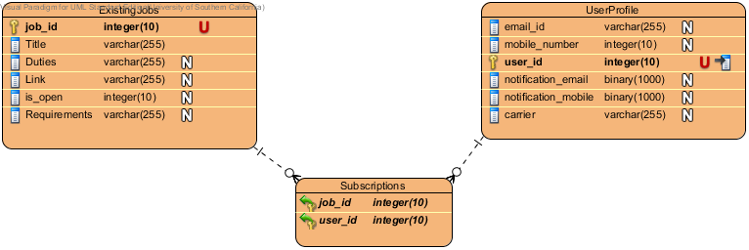

**Figure 2: Artifacts and Information Diagram**

|  |  |
| --- | --- |
| **Artifact** | **Purpose** |
| ExistingJobs | Table of all the currently existing jobs in the City of LA. Will be mirrored from the existing database. |
| UserProfile | Table containing the user profile as saved by the user. |
| Subscriptions | This table has a list of users and jobs which the user has subscribed for notifications to. |

**Table 2: Artifacts and Information Summary**

**2.1.3. Behavior**

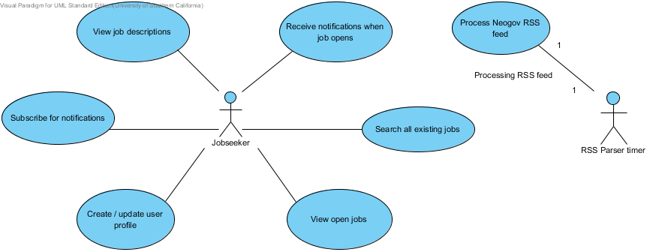

**Figure 3: Process Diagram**

### Image2.png View open jobs

#### Use Case Descriptions

|  |  |
| --- | --- |
| Main | |
| **Super Use Case** | None |
| **Brief Description** | The user can view a listing of currently open jobs. |
| **Preconditions** | UC07 is performed. |
| **Post-conditions** | User will view a listing of all currently open jobs. |
| **Flow of Events** | |  |  |  | | --- | --- | --- | |  | Actor Input | System Response | | 1 | User clicks "View open jobs" on the home screen. |  | | 2 |  | UI sends request to the server. | | 3 |  | Server parses RSS feed. | | 4 |  | Server sends a list of the open jobs to the UI. | | 5 |  | UI displays the open jobs titles on a separate screen. | |

|  |  |
| --- | --- |
| Alternative | |
| **Brief Description** | If UI is unable to fetch the details from the server. |
| **Preconditions** | UC08 is performed. |
| **Post-conditions** | None |
| **Flow of Events** | |  |  |  | | --- | --- | --- | |  | Actor Input | System Response | | 1 | User clicks "View open jobs" on the home screen. |  | | 2 |  | UI sends request to the server. | | 3 |  | UI does not receive a reply after a suitable time out. | | 4 |  | UI resends the request (3 times). | | 5 |  | If the UI still doesn't receive a reply it displays an error message and encourages the user to retry at a later time. | |

### Process Neogov RSS feed



#### Use Case Descriptions

|  |  |
| --- | --- |
| Main | |
| **Super Use Case** | None |
| **Brief Description** | The server processes the Neogov RSS feed for the open jobs listing every friday. |
| **Preconditions** | None |
| **Post-conditions** | Open jobs get updated, notifications are sent accordingly |
| **Flow of Events** | |  |  |  | | --- | --- | --- | |  | Actor Input | System Response | | 1 | Function to retrieve RSS feed from Neogov is triggered every Friday at 0001 in the application server. |  | | 2 |  | Neogov RSS feed is fetched and stored as an XML file on the server. | | 3 |  | The XML file is parsed and the open job ids are saved. | | 4 |  | The system triggers the notification function to send required notifications. | |

|  |  |
| --- | --- |
| Exceptional flow | |
| **Brief Description** | Server is unable to retrieve the RSS feed. |
| **Preconditions** | It is friday 0001 PST and server triggers RSS feed retrieval |
| **Post-conditions** | The server either retrieves the feed or keeps trying every 30 minutes. |
| **Flow of Events** | |  |  |  | | --- | --- | --- | |  | Actor Input | System Response | | 1 | Function to retrieve RSS feed from Neogov is triggered. |  | | 2 |  | Server tries to retrieve the RSS feed from the Neogov server. | | 3 |  | Server is unable to retrieve the feed. Retries 3 times. | | 4 |  | Server is still unable to retrieve the feed. It retries again every 30 minutes until it is able to retrieve the feed. | |

### Image2.png Receive notifications when job opens

#### Use Case Descriptions

|  |  |
| --- | --- |
| Main | |
| **Super Use Case** | None |
| **Brief Description** | The user will receive a notification either through email or text message when a job he has subscribed for opens. |
| **Preconditions** | UC07 and UC05 |
| **Post-conditions** | User receives a notification through text or email. |
| **Flow of Events** | |  |  |  | | --- | --- | --- | |  | Actor Input | System Response | | 1 | Job seeker subscribed for notification to a job that just opened on the View Job Description page. |  | | 2 |  | RSS feed is downloaded and parsed. A list of open jobs is obtained. | | 3 |  | Server searches through the user profile database for users who have requested to be updated about this job. | | 4 |  | If such users are found, server checks the method of notification selected. | | 5 |  | Server sends an email or text message, whichever is requested, with job id, title and a link to apply for the job. | |

### Image2.png View job descriptions

#### Use Case Descriptions

|  |  |
| --- | --- |
| Main | |
| **Super Use Case** | None |
| **Brief Description** | The user should be able to view a brief job description and use a link to connect to the job description page on the web site. |
| **Preconditions** | The user performs a search and selects a given job from the search results. (UC03 and UC04) |
| **Post-conditions** | The user can view a brief description of the job he is interested in. |
| **Flow of Events For a currently open job** | |  |  |  | | --- | --- | --- | |  | Actor Input | System Response | | 1 | User clicks on job from the jobs search result. |  | | 2 |  | UI sends request to the server. | | 3 |  | Server responds with the requested job details from the XML saved from the RSS feed. | | 4 |  | UI displays these details in the job description page. | | 5 |  | Job description page contains job id, title, salary details, location of job, last date of application, category of job, a brief description of the job role and a link to apply for the job. These details are available in the Neogov RSS feed. | | 6 | User clicks "Apply now" link. |  | | 7 |  | Redirects to the existing web site from where the candidate can apply for the post. | |
| **Flow of Events**  **For unopen jobs** | |  |  |  | | --- | --- | --- | |  | Actor Input | System Response | | 1 | User clicks on job from the jobs search result. |  | | 2 |  | UI sends request to the server. | | 3 |  | Server responds with the requested job details from the job listing database. | | 4 |  | UI displays these details in the job description page. | | 5 |  | Job description page contains job id, title, a brief description of the job role and a link to the job details in the existing web site. It also contains a subscribe button. | | 6 | User clicks the web site link. |  | | 7 |  | Redirects to the existing web site from where the candidate can view further details about the post. | |

### Image2.png Search all existing jobs

#### Use Case Descriptions

|  |  |
| --- | --- |
| Main | |
| **Super Use Case** | None |
| **Brief Description** | The user can search through a database of all existing (including open ones) jobs in the city of LA. He can use job ID or keywords to perform the search. |
| **Preconditions** | Job listings database is populated. |
| **Post-conditions** | User will view jobs matching his search criteria (if any). |
| **Flow of Events** | |  |  |  | | --- | --- | --- | |  | Actor Input | System Response | | 1 | User clicks on "Search for Jobs" in the home page. |  | | 2 |  | UI redirects to the search page. | | 3 | User enters the search term (job id or keyword) and presses enter. |  | | 4 |  | UI validates if search term is non-empty. | | 5 |  | UI sends the search term to the server. | | 6 |  | The server searches the job_id and title of the job listings database. | | 7 |  | The server sends back a list of matching jobs. | | 8 |  | UI displays the jobs in the search result age. If no job is returned it displays "No matching jobs". | |

### Image2.png Create / update user profile

#### Use Case Descriptions

|  |  |
| --- | --- |
| Main | |
| **Super Use Case** | None |
| **Brief Description** | The user can create a profile containing the email id and / or the mobile number he would like to use to receive notifications. Optional. |
| **Preconditions** | User is on home page |
| **Post-conditions** | If an email id or mobile number is added by the user, it should be automatically used to send notifications when the user subscribes for a job |
| **Flow of Events** | |  |  |  | | --- | --- | --- | |  | Actor Input | System Response | | 1 | Clicks "User Profile" on the home page. |  | | 2 |  | UI takes user to the Profile page. | | 3 | User inputs email id and / or mobile number. He can also input notification preferences. |  | | 4 | User clicks save. |  | | 5 |  | UI checks if email id and number are valid. | | 6 |  | If details are valid. UI sends a copy of the details entered to the server in an encrypted fashion. | | 7 |  | Server checks if email id and mobile number are already present in the User database. | | 8 |  | If details are not present it inputs them in the User database. If the same email id or mobile number is present then it updates the database accordingly. | | 9 |  | Server sends a message saying details were saved. | | 10 |  | UI saves a copy of the details on the phone. | | 11 |  | UI displays a success message. Then redirects to the home page. | |

|  |  |
| --- | --- |
| Alternative | |
| **Brief Description** | If invalid email or mobile numbers are entered |
| **Preconditions** | User inputs invalid details |
| **Post-conditions** | None |
| **Flow of Events** | |  |  |  | | --- | --- | --- | |  | Actor Input | System Response | | 1 | Clicks "User Profile" on the home page. |  | | 2 |  | UI takes user to the Profile page. | | 3 | User inputs email id and / or mobile number. He can also input notification preferences. |  | | 4 | User clicks save. |  | | 5 |  | UI checks if email id and number are valid. | | 6 |  | If invalid, displays a message "The details inputted are invalid. Please re-enter valid detail." | | 7 |  | Displays the Profile page. | |

### Image2.png Subscribe for notifications

#### Use Case Descriptions

|  |  |
| --- | --- |
| Main | |
| **Super Use Case** | None |
| **Brief Description** | The user subscribes for a notification when a particular job opens either through email or text messages. |
| **Preconditions** | User is viewing the job description page of an existing but unopen job. |
| **Post-conditions** | User will receive a notification when the job opens. |
| **Flow of Events** | |  |  |  | | --- | --- | --- | |  | Actor Input | System Response | | 1 | User clicks subscribe on the "Job Description" page. |  | | 2 |  | UI redirects to the subscription page. | | 3 |  | If user profile exists, UI inputs the email id and the mobile number in the form.  Else, it provides a form to input these values. | | 4 | User chooses whether they want email or text message notification. |  | | 5 | User enters profile details if needed and clicks on subscribe. |  | | 6 |  | UI sends job id, subscription method and user details to the server in an encrypted fashion. | | 7 |  | Server saves details in the user profile table and sends success message. | | 8 |  | UI displays success message. Redirects to job description page. | |

|  |  |
| --- | --- |
| Alternative | |
| **Brief Description** | UI receives a failure message or no message at all. |
| **Preconditions** | UI sends profile and subscription details to the system. |
| **Post-conditions** |  |
| **Flow of Events** | |  |  |  | | --- | --- | --- | |  | Actor Input | System Response | | 1 | Steps 1-5 as in main flow. |  | | 2 |  | UI sends job id, subscription method and user details to the server in an encrypted fashion. | | 3 |  | UI doesn't receive a message till time-out or receives an error message from the server. | | 4 |  | UI displays error message and suggests that the user retry the operation at a later time. | |

**2.1.4 Modes of Operation**

The application has a single mode of operation. The only user is the job-seeker

**2.2 System Analysis Rationale**

The proposed system considers two types of jobs:

Existing Jobs: These are all the jobs that already exist in the City of Los Angeles. It consists of both the jobs for which openings are currently open as well as jobs which do not have any openings at present. A job-seeker can search through this list of jobs using keywords and subscribe for jobs which are not currently open.

Open Jobs: This is a subset of the Existing Jobs. It includes jobs which currently have a vacancy and for which the City of Los Angeles is accepting applications.

**3.Technology Independent Model**

**This section is left blank as the technology specific design of the system contains the relevant details. Please refer to section 4 below.**

**4. Technology-Specific System Design**

**4.1. Design Overview**

**4.1.1. System Structure**

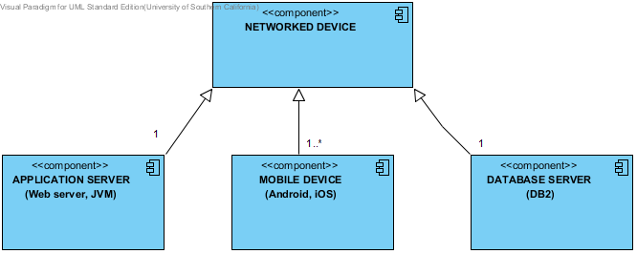

**Figure 4: Hardware Component Diagram**

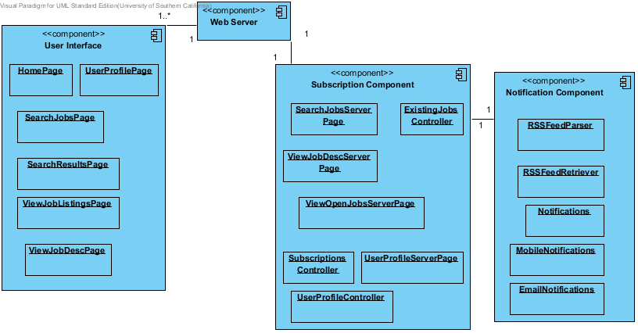

**Figure 5: Software Component Class Diagram**

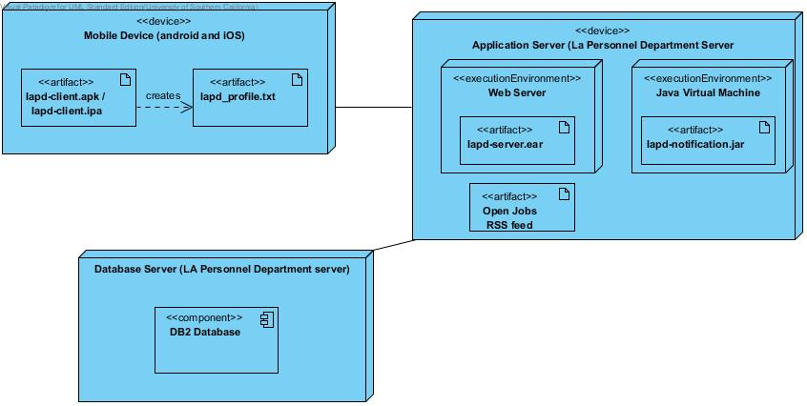

**Figure 6: Deployment Diagram**

|  |  |
| --- | --- |
| **Hardware Component** | **Description** |
| Application Server | Web server with JVM which will contain the server side code for our system. Code will be in Java and JSP. |
| Mobile Device | Android or iOS based mobile device which will contain the client side native application for our system. Code in HTML, CSS and Javascript. |
| Database Server | DB2 server provided by the client containing the tables used by our system. |

**Table 3: Hardware Component Description**

|  |  |
| --- | --- |
| **Software Component** | **Description** |
| User Interface | The client side application with which the user will interact to view and subscribe for notifications. |
| Subscription Component | The server side component which will handle saving the user profile, searching for jobs and subscription for notifications. |
| Notification Component | The server side component which will handle fetching and parsing the open jobs feed and sending the required notifications. |

**Table 4: Software Component Description**

**4.1.2 Design Classes**

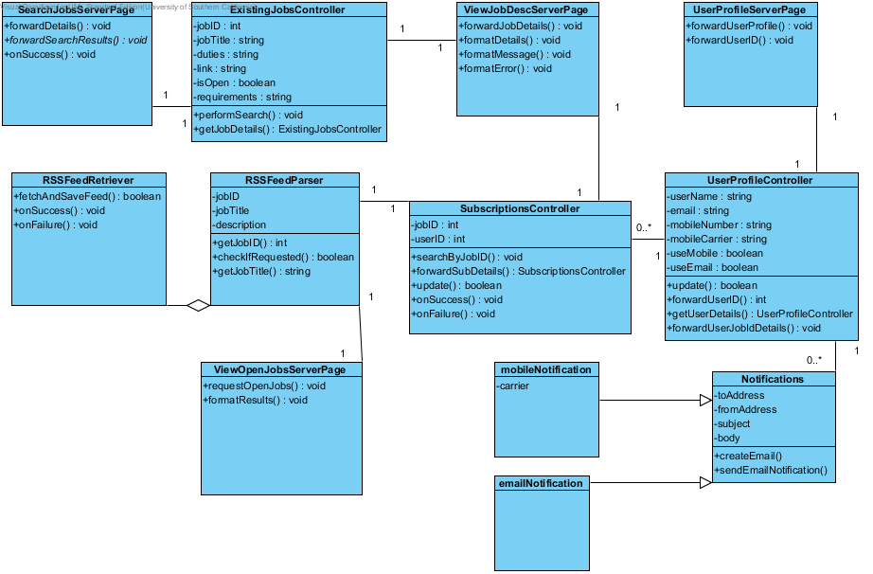

**Figure 7: Design Class Diagram**

|  |  |  |
| --- | --- | --- |
| **Class** | **Type** | **Description** |
| SubscriptionsController | Control | This class updates and retrieves data from the subscriptions table. |
| UserProfileController | Control | This class updates and retrieves data from the UserProfile table. |
| UserProfileServerPage | Control | This class passes data from the UserProfilePage to the UserProfile |
| ExistingJobsController | Control | This class updates and retrieves data from the ExistingJobs table. |
| ViewJobDescServerPage | Control | This class interacts with ExistingJobsController and RSSParser to display job details as applicable. |
| SearchJobsServerPage | Control | This class interacts with the ExistingJobsController to retrieve a list of jobs meeting a particular search criteria. |
| ViewOpenJobsServerPage | Control | This class interacts with the RSSParser class to retrieve a list of currently open jobs to display to the user. |
| RSSFeedParser | Control | This class parses the RSS feed and checks which jobs are open. It then triggers notifications if required. |
| RSSFeedRetriever | Control | This class downloads and saves the RSS feed with information about the currently open jobs. |
| Notifications | Control | Abstract class to send notifications. |
| EmailNotifications | Control | Class to send notification be email. |
| MobileNotifications | Control | Class to send notification by mobile. |

**Table 5: Design Class Description**

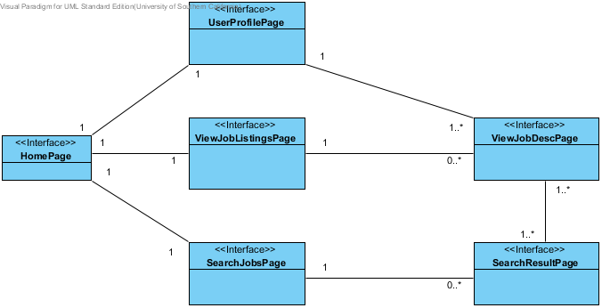

**Figure 8: Interface Class Diagram**

|  |  |  |
| --- | --- | --- |
| **Class** | **Type** | **Description** |
| HomePage | Boundary | The first page of the application. |
| UserProfilePage | Boundary | Allows the user to create and update their profile. |
| ViewJobListingsPage | Boundary | Allows user to view all the currently open job titles. |
| SearchJobsPage | Boundary | Has a search bar for the user to input keywords for searching the ExistingJobs database. |
| SearchResultPage | Boundary | Allows user to view all the job titles returned by the search query. |
| ViewJobDescPage | Boundary | Contains a description of the job. Allows users to subscribe for a notification if the job is not open. |

**Table 6: Interface Class Description**

**4.1.3 Process Realisation**

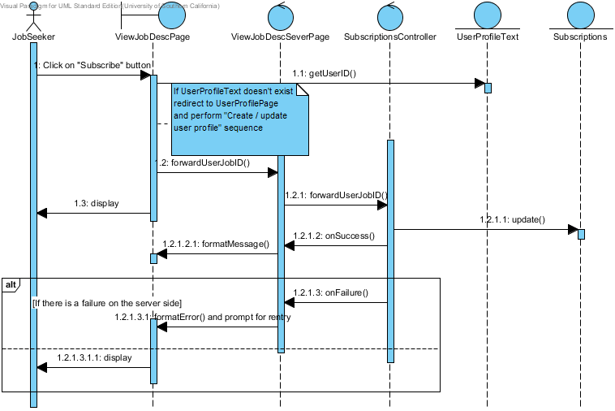

**Figure 9: Process Realisation - Subscribe for notification**

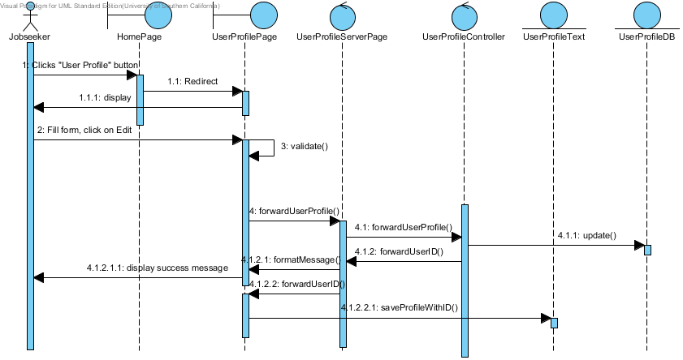

**Figure 10: Process Realisation – Create / Update user profile**

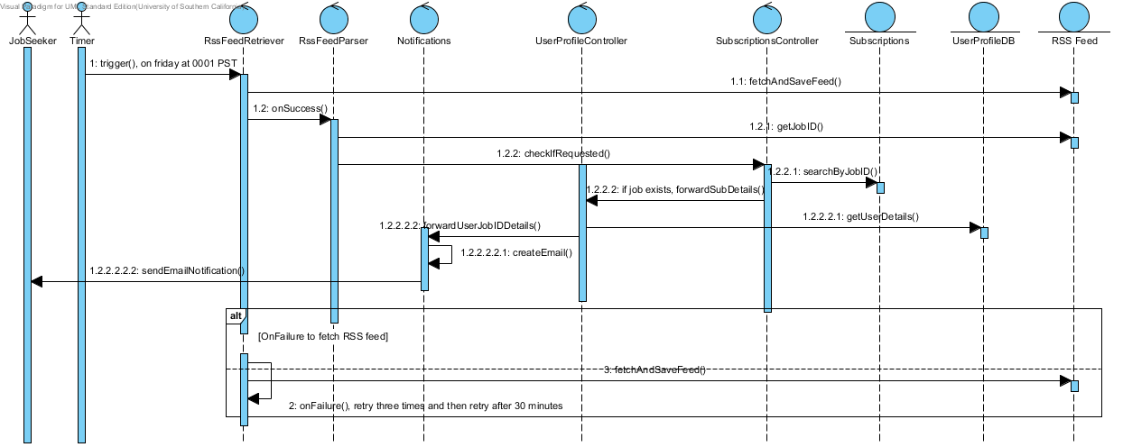

**Figure 11: Process Realisation – Process RSS feed and Send Notifications**

**4.2 Design Rationale**

We have adopted a layered architecture with a state-logic-display pattern. The 3 layers are:

* Display layer: Client side application containing the user interface.
* Logic layer: Server side java application containing the two components – subscription component and notification component.
* State layer: A DB2 database containing tables with the required information.

We have chosen this three layered architecture to clearly separate the client side of the application from the server code and the database does ensuring that the client has no direct access to the database.

To ensure that our application works on both Android and iOS we have chosen to use a COTS called Phonegap. Phonegap provides us with a means to develop for both Android and iOS simultaneously does ensuring that both the apps behave and look the same.

For the process realisation diagram we have added sequence diagrams for two of the riskiest functionalities of our application.

These are:

Subscription for Notification: This consists of two sequence diagrams, one covering the subscription for notifications and the other covering the creation / updation of the user profile used for the subscription

Processing RSS feed and sending Notifications: This consists of the server downloading and parsing the RSS feed and sending notifications to the users who have subscribed for a job which has opened.

**5. Architecture Styles, Patterns and Frameworks**

|  |  |  |
| --- | --- | --- |
| **Name** | **Description** | **Benefits, Costs, and Limitations** |
| Layered style  (state-logic-display pattern) | The system is divided into three separate layers. Each layer communicates only with the ones immediately above and below it.  The layers are: client side application (display), java server side application (logic) and DB2 database (state) | **Benefits:** Clear separation of the display, logic and data store in the application. Also ensures security as only the server side code can access the database. Clients have no direct access to the database.  **Costs:** Each time the client needs to interact with the database it has to go through the server. |
| Client-server style | The mobile devices act as clients which access the application server to perform tasks. | **Benefits:** Any number of clients can access the server at a given point of time. Server does not need to keep track of the client’s state as the client will provide all information to the server.  **Costs:** Single point of failure. If the server goes down the entire application will fail. |
| Publish-subscribe style | The job-seeker subscribes for notifications. The server keeps a track of these subscriptions and publishes notifications when the job opens. | **Benefits:** Since some jobs may open rarely the job-seeker doesn’t need to check for the job repeatedly. The server will inform the client when the job opens.  **Limitations:** The server is completely responsible for sending notifications. May overload the server. |

**Table 7: Architectural Styles, Patterns, and Frameworks**